**Steps:**

* Having a running instance, click on it
* Scroll down and click on storage, you should see a running EBS, click on the volume ID to go to the EBS section on the left

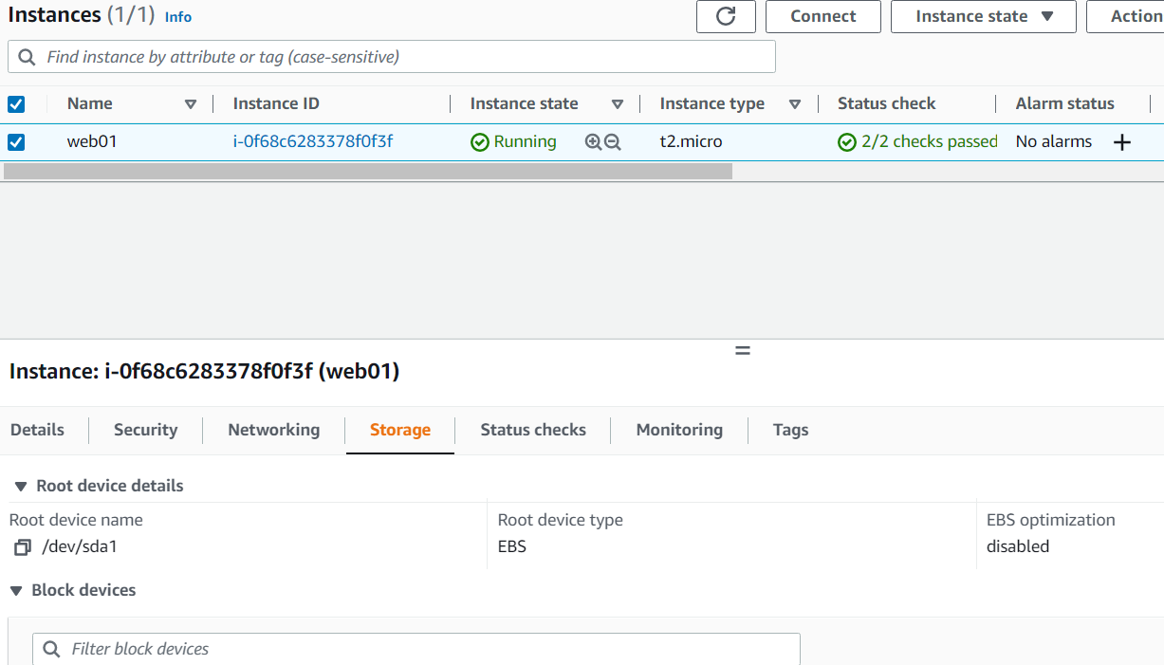

* Click on the pencil icon beside your EBS instance and give a proper name: (web01-ROOT—Volume)

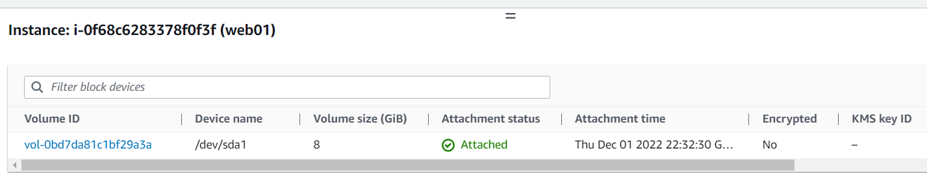

* Check your project requirement and click on create Volume to provide your settings:

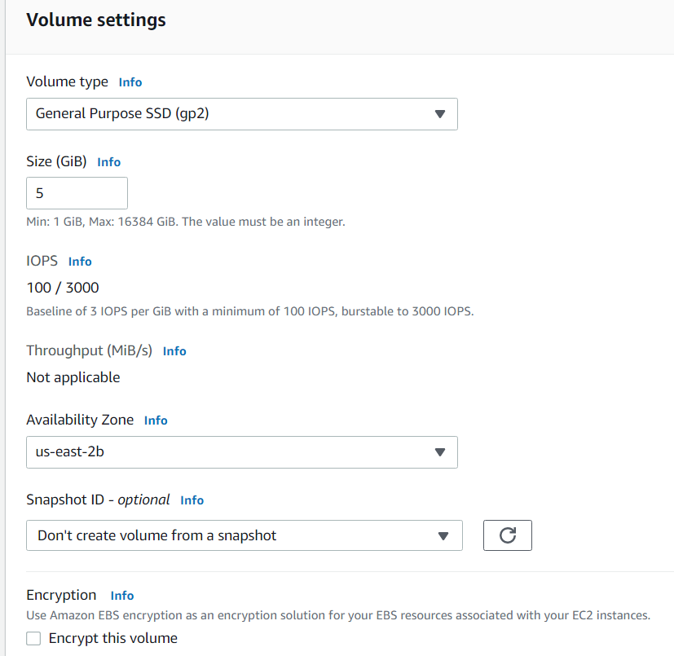

* Click on Additional Tags to provide one, when done click on Create Volume

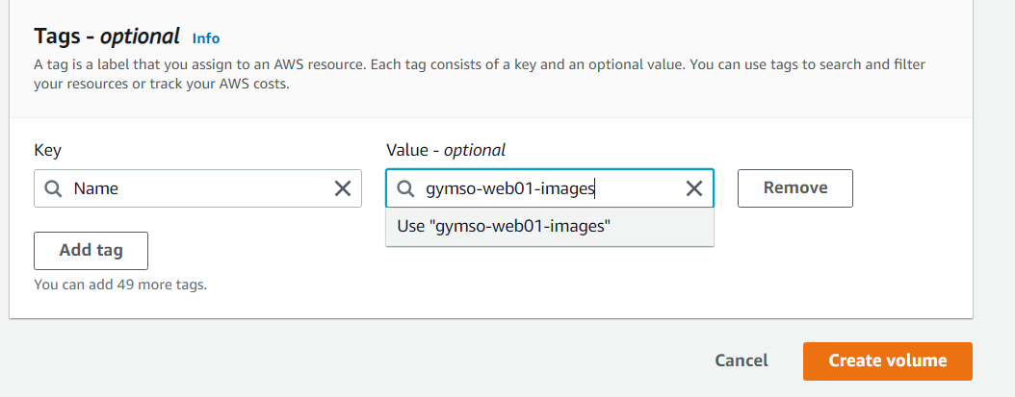

* Select the newly created volume and click on Actions …….. Attach Volumes

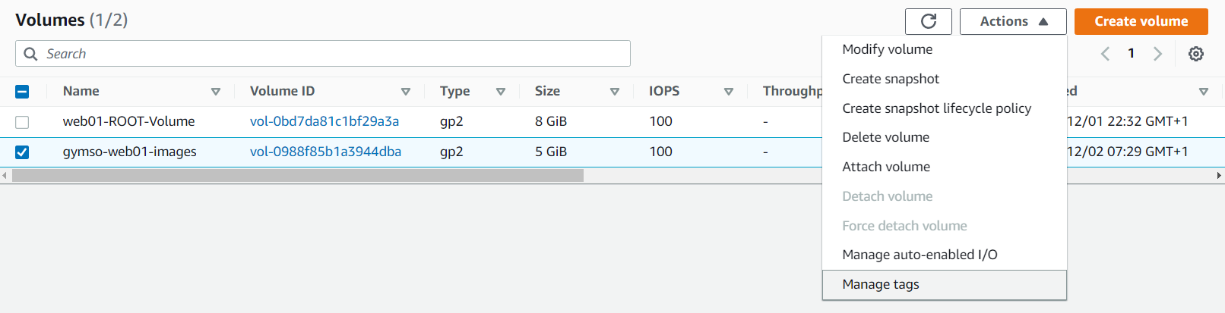

* Select the instance you which to attach your volume to and proceed

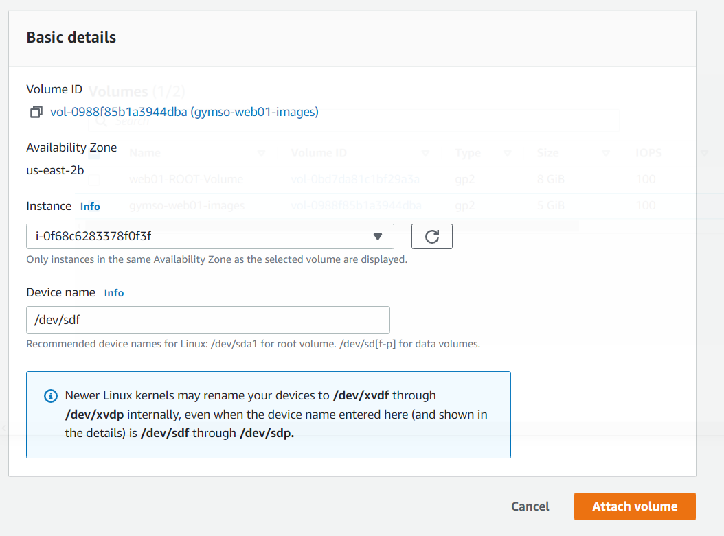

* Go to git bash
* SSH to the created volume using a keypair created (I need to research more on these):
* ssh –i Downloads/gymso-dev-nvir.pem [centos@54.165.48.12](mailto:centos@54.165.48.12)
* sudo –i
* cd /var/www/html
* ls ……. To view and select the images folder to be placed in the created volume
* fdisk –l …….. to see all your disks
* df –h ……. To see where your ROOT is mounted to and the partitions
* fdisk /dev/xvdf …….. xvdf is the path (These command opens the disk utility)
* m ….. for help
* n …… to add a new partition
* p …… to select partition type
* 1 ….. to give the default partition since it is a fresh volume
* Press ENTER
* Under last sector put …….. +3G …. To specify size or press ENTER to provide default
* fdisk –l …….. to see all your disks
* mkfs hit tab 2ce ……. disk formatting options
* mkfs.ext4 /dev/xvdf1 ……..make sure you use the right disk path (/dev/xvdf1)
* format is done, it is time to mount it. It will be mounted on images
* cd /var/www/html
* mkdir /tmp/img-backups
* mv images/* /tmp/img-backups/
* ls images/ …. should be empty
* cd

Step 1: Temporary mount

* mount /dev/xvdf1 /var/www/html/images/ ……… this is temporary mount once i reboot it’ll be gone
* df –h ……. to see if it was mounted
* mv /tmp/img-backups/* /var/www/html/images/ ….. to move to the mounted volume
* if you want to unmount a directory use:
* umount /var/www/html/images

Step 2: Permanent mount

* vi /etc/fstab
* press i for insert mode, move to the last line after what you see,
* partition path where you want to mount format type options dump / Fstc code

/dev/xvdf1 /var/www/html/images ext4 defaults 0 0

* Escape + :wq + ENTER ….. to save
* mount –a …… to mount your entries
* df –h ……. to check
* mv /tmp/img-backups/* /var/www/html/images/ ….. to move to the mounted volume
* systemctl restart httpd ….. to accept changes
* ls /var/www/html/images/ …… to confirm
* get the ip and check in the browser, make sure the images are showing
* if you are not seeing images in the browser, it means SELINUX is preventing it, follows steps below:
* vi /etc/selinux/config
* change enforcing to disable (SELINUX=Enforcing)
* save and quit
* reboot …. to reboot your machine

**To unmount:**

* df –h
* umount /var/www/html/images …………. if these option doesn’t work, it means a user is accessing it. use the next option to force it.
* yum install lsof –y
* cd /var/www/html/images
* lsof /var/www/html/images